IT 140 Design Document Template

Instructions
Fill out the sections below. Be sure to remove the bracketed text before submitting your Design Document.

[Insert Your Name Here]

Storyboard (Description and Map)
[Include a paragraph description of your theme, storyline, rooms, items, and villain here. Be sure to also complete the map below with your rooms and items. You may add more rooms and directions if you like. Use the Insert menu and select Shapes to add textboxes and arrows.]

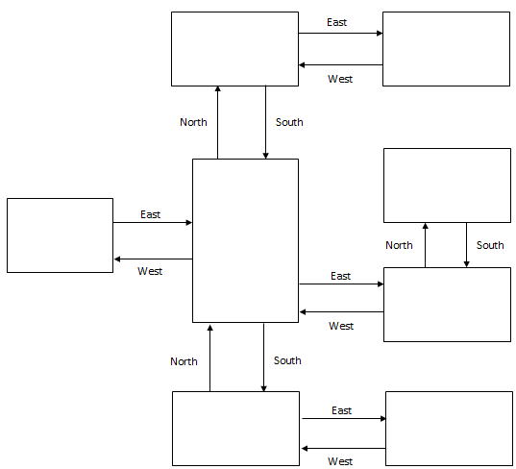

Pseudocode or Flowchart for Code to “Move Between Rooms”
[Write pseudocode or create/insert your flowchart here.]

Pseudocode or Flowchart for Code to “Get an Item”
[Write pseudocode or create/insert your flowchart here.]

